**IST659 – Data Admin Concepts & Db Mgmt**

**Lab2 - Ramasamy Seenivasagamani – Sanjeev**

**Problem 1:** **Twitter**

1. **ERD:**



1. **Tables – Datasheet View:**

* **Profile**

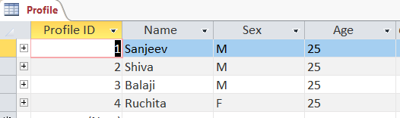

* **Follower**

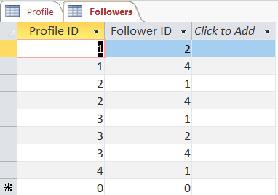

1. **Relationship Report:**

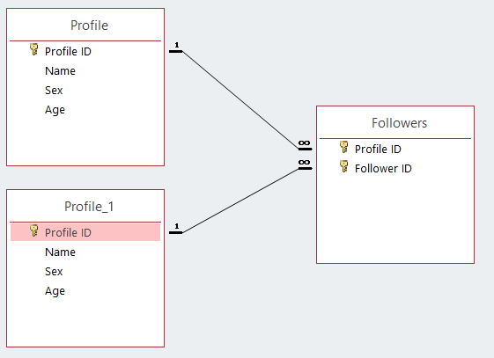

**Problem 2: Library System**

1. **ERD:**



1. **Tables – Datasheet View:**

* **Books**

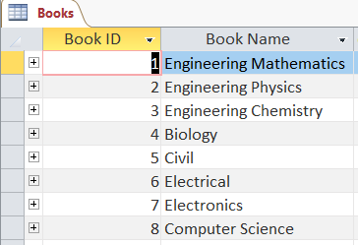

* **Customer**

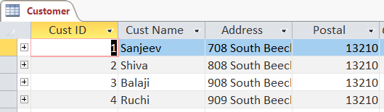

* **Ledger**

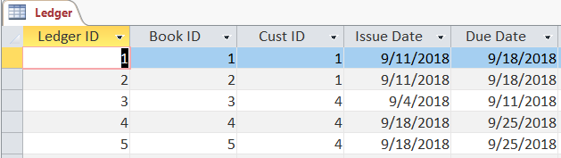

1. **Relationship Report:**

